Report Card / Form 138 (front)
Note: This photo is only for references only.

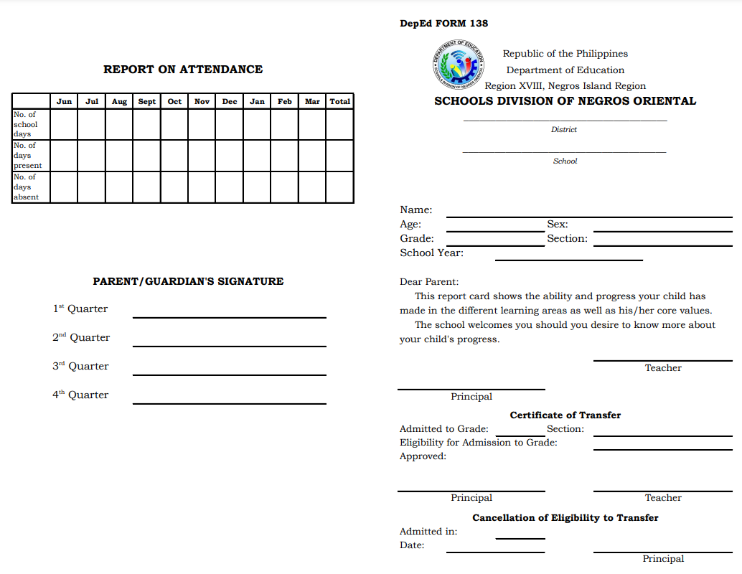

Report Card / Form 138 (back)
Note: This photo is only for references only.

